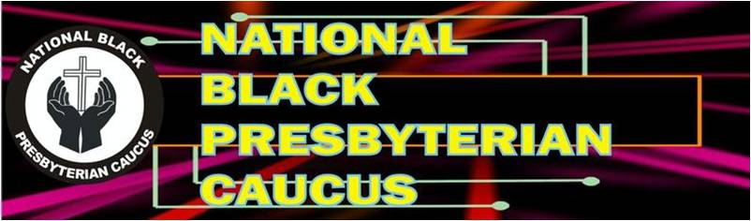
2024 BALLOT

FOR VICE PRESIDENT-Please Vote or Write In
- Ruling Elder Ray Williams
- Write-in Candidate_______________________________
*************************************************************************************
FOR SECRETARY-Please Vote or Write In

- Ms. Sarah Rucker
- Write-in Candidate:_____________________________
*************************************************************************************

Ballot submitted by: __________________________ Phone:______________________

The deadline for returning ballots is July 31, 2024
Please send forms my email or U.S. Postal Mail to:
The Reverend Patricia B. Jones
NBPC Nominating Committee Chairperson
3411 Farmers Market Drive, Charleston, SC 29414
Email: pbligenjones@gmail.com

July 15, 2024
RE: Nominations and Ballot

Dear NBPC Member:
Attached are the names and bios of members who have been nominated and the Ballot. The Committee has confirmed that each candidate will accept the position to serve if elected. Additionally, there is still an opportunity for you to write-in a candidate if:
- Your nominee meets the requirements listed on the nominating form previously sent.
- Your have his or her approval to nominate them and they will serve if elected.
- You must attach a brief bio of person you nominate
Thank you for your participation in this election cycle.

For Vice President:
Ruling Elder Ray Williams
For Secretary:
Sarah Rucker
The deadline for returning your ballot is July 31, 2024. You may return your ballot by email or the U.S. Postal Service to the address below:
The Reverend Patricia B. Jones
3411 Farmers Market Drive
Charleston, SC, 29414
Email: pbligenjones@gmail.com

Respectfully,

Reverend Patricia B. Jones

Bios NBPC Nominees for Offices of Vice President and Secretary

Ruling Elder Ray Williams is a member of 5th Avenue Presbyterian Church in Roanoke, Virginia. He is a Commissioned Lay Pastor who supplies Holbrook Presbyterian Church (USA) in Danville, VA. In addition to his efforts to contribute to the life and growth of Holbrook Church, he does his best to serve God and the greater Presbyterian Church. Accordingly, he is a member of the Presbytery of the Peaks, serving as a Justice and Racial Subcommittee member. He has been an active member of the NBPC for many years and currently serves as the President of the Peaks Presbytery NPBC.

Ms. Sarah Rucker is a native of Johns Island, SC. She is a member of Hebron Zion Presbyterian Church (USA), where she serves as a member of the Personnel Committee. She is a professor at Clinton College in Rock Hill, SC. In 2022, she was nominated and elected by the Charleston Atlantic Presbytery to serve as a Young Adult Delegate to the 225th General Assembly. She is a Winthrop University graduate with a Bachelor of Science in Business Administration and a Master of Business Administration degree. Sarah loves volunteer work and is passionate about uplifting youth because she believes they have much to offer their community. Sarah’s favorite scripture is Romans 8:28: “For we know all things work together for good to them that love God, to them who are called according to his purpose.”

