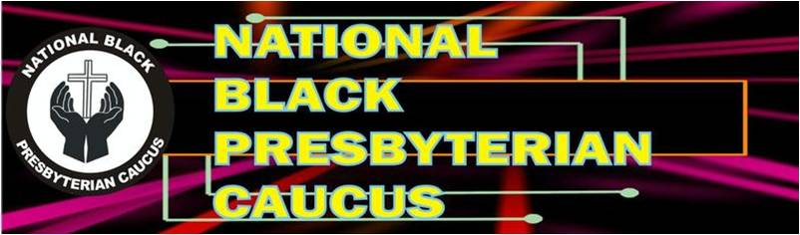
2024 BALLOT

FOR VICE PRESIDENT-Please Vote or Write In
- Ruling Elder Ray Williams
- Write-in Candidate_______________________________
*************************************************************************************
FOR SECRETARY-Please Vote or Write In

- Ms. Sarah Rucker
- Write-in Candidate:_____________________________
*************************************************************************************

Ballot submitted by: __________________________ Phone:______________________

The deadline for returning ballots is July 31, 2024
Please send forms my email or U.S. Postal Mail to:
The Reverend Patricia B. Jones
NBPC Nominating Committee Chairperson
3411 Farmers Market Drive, Charleston, SC 29414
Email: pbligenjones@gmail.com

