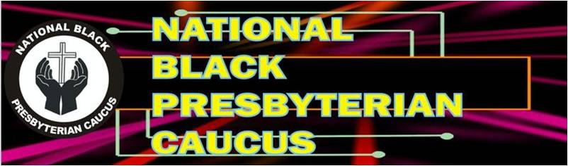

Bios NBPC Nominees for Offices of Vice President and Secretary

Ruling Elder Ray Williams is a member of 5th Avenue Presbyterian Church in Roanoke, Virginia. He is a Commissioned Lay Pastor who supplies Holbrook Presbyterian Church (USA) in Danville, VA. In addition to his efforts to contribute to the life and growth of Holbrook Church, he does his best to serve God and the greater Presbyterian Church. Accordingly, he is a member of the Presbytery of the Peaks, serving as a Justice and Racial Subcommittee member. He has been an active member of the NBPC for many years and currently serves as the President of the Peaks Presbytery NPBC.

Ms. Sarah Rucker is a native of Johns Island, SC. She is a member of Hebron Zion Presbyterian Church (USA), where she serves as a member of the Personnel Committee. She is a professor at Clinton College in Rock Hill, SC. In 2022, she was nominated and elected by the Charleston Atlantic Presbytery to serve as a Young Adult Delegate to the 225th General Assembly. She is a Winthrop University graduate with a Bachelor of Science in Business Administration and a Master of Business Administration degree. Sarah loves volunteer work and is passionate about uplifting youth because she believes they have much to offer their community. Sarah’s favorite scripture is Romans 8:28: “For we know all things work together for good to them that love God, to them who are called according to his purpose.”

